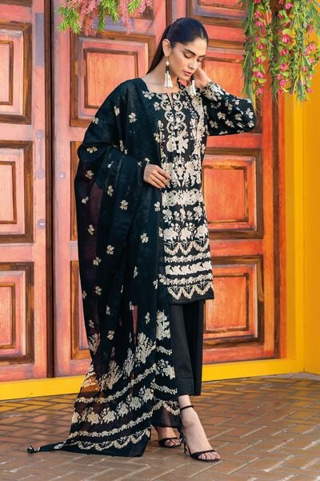

The traditional three-piece dress for women in Pakistan is a timeless and elegant ensemble. In the context of your query, let's explore a specific variation of this dress in black color with a printed shirt and lawn fabric, priced at PKR 5500.

this three-piece dress offers a blend of traditional aesthetics and contemporary fashion. The black color exudes elegance and sophistication, while the printed shirt in lawn fabric showcases the intricate craftsmanship of Pakistani artisans. This ensemble is perfect for various occasions, be it formal gatherings, cultural events, or festive celebrations, allowing women to embrace their cultural heritage with style and grace.

* **Details**
  + **Top Fabric:** Printed Lawn | Length 1.75m | Width 58in
  + **Bottom Fabric:** Dyed Cambric | Length 1.6m | Width 58in
  + **Dupatta Fabric:** Printed Lawn | 2.5m
  + **Campaign:** The Print Story